Advocacy support  LLAIS, Citizen’s Voice for Health and Social Care in Wales provide advocacy support, visit their website for local details http://www.wales.nhs.uk/sitesplus/899/home  Meic is the helpline service for children and young people up to the age of 25 in Wales 0808 80 23456  Age Cymru may have advocates in the area. Visit their website or call 0300 303 44 98  Further action  If you are dissatisfied with the outcome of your complaint from either NHS Wales or this practice, then you can escalate your complaint to:  Public Services Ombudsman for Wales  1 Ffordd yr Hen Gae  Pencoed  CF35 5LJ  Tel 0300 790 0203 or email ask@ombudsman-wales.org.uk | CWMFELIN MEDICAL CENTE  298 Carmarthen Road, Swansea, SA1 1HW  01792 653941 reception.emailw98003@wales.nhs.uk |  | The Complaints Process  - Cwmfelin Medical Centre

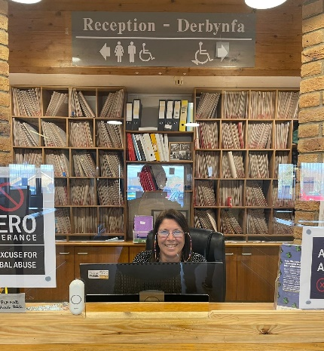

Talk to us
Every patient has the right to make a complaint about the treatment or care they have received at Cwmfelin Medical Centre.
We understand that we may not always get everything right and, by telling us about the problem you have encountered, we will be able to improve our services and patient experience.

Who to talk to
Most complaints can be resolved at a local level. Please speak to a member of staff if you have a complaint; our staff are trained to handle complaints. Alternatively, ask to speak to the complaint’s manager, Shannon Thomas or office Leanne Smith.
If for any reason you do not want to speak to a member of our staff, then you can request that the Local Health Board investigates your complaint. They will contact us on your behalf:
Swansea Bay University Health Board Telephone: 01639 683316/683316 Text: 07903594520 Email: SBU.complaints@wales.nhs.uk
A complaint can be made verbally or in writing. A complaints form is available from reception or on our website Cwmfelin.co.uk. Additionally, you can complain via email to reception.emailw98003@wales.nhs.uk

Time frames for complaints
The time constraint on bringing a complaint is 12 months from the occurrence giving rise to the complaint, or 12 months from the time you become aware of the matter about which you wish to complain.
The complaints manager will acknowledge any complaints within two business days.
We will aim to investigate and provide you with the findings as soon as we can and will provide regular updates regarding the investigation.
Investigating complaints Cwmfelin Medical Centre will investigate all complaints effectively and in conjunction with extant legislation and guidance.
Confidentiality Cwmfelin Medical Centre will ensure that all complaints are investigated with the utmost confidentiality and that any documents are held separately from the patient’s healthcare record.
Third party complaints Cwmfelin Medical Centre allows a third party to make a complaint on behalf of a patient. The patient must provide consent for them to do so. A third-party patient complaint form is available from reception.
Final response Cwmfelin Medical Centre will issue a final formal response to all complainants which will provide full details and the outcome of the co

